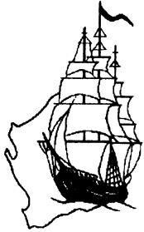
Swan River Pioneers 1829 – 1838 Inc.
PO Box 2672, Ellenbrook WA 6069

An Affiliated Member of the Western Australian Genealogical Society Inc.

APPLICATION FOR CERTIFICATE OF DESCENDANCY

I, _______________________________________________________________________________________
(full name of applicant – block letters)
of______________________________________________________________________________________
(address)
State/Country________________________________Postcode_________________Telephone:____________________

Email Address:____________________________________________________________________________________

I wish to apply for a Certificate of Descendancy

I wish to have my Certificate presented at the Annual Foundation Day Function (tick application boxes)

DETAILS OF PIONEER FROM WHOM DESCENT IS CLAIMED:

Surname:

Given Names:

Arrival or earliest date known in the Swan River Colony:

- date

- ship

DESCENDANCY STATEMENT:
I am a direct descendant of: who resided in the Swan River Colony of Western Australia prior to 31st December 1838.
Relation to applicant as shown in statement or lineal descent on reverse side (page 2) of the application. Attached to my application is an outline of the proofs required and I declare that the statements made by me are true and correct. Please make cheques payable to: Swan River Pioneers 1829-1838
In the event of my application being approved, I agree to be bound by the rules of the Swan River Pioneers Group for the time being in force.
I give permission for information in my file to be photocopied or used for research by authorised Swan River Pioneer
Research Officers.
Yes / I do give permission
No/ I do not give permission (cross out applicable)

Signature of applicant: Date:

For Examiners & Convenors use only:
Application No:__________________ Date: ______________ Receipt No: ___________

Proofs Accepted:__________________________ Certificate Numbers:_________________________________________

Direct Line of Descent: No 1 being the first pioneer to arrive in the Swan River Colony
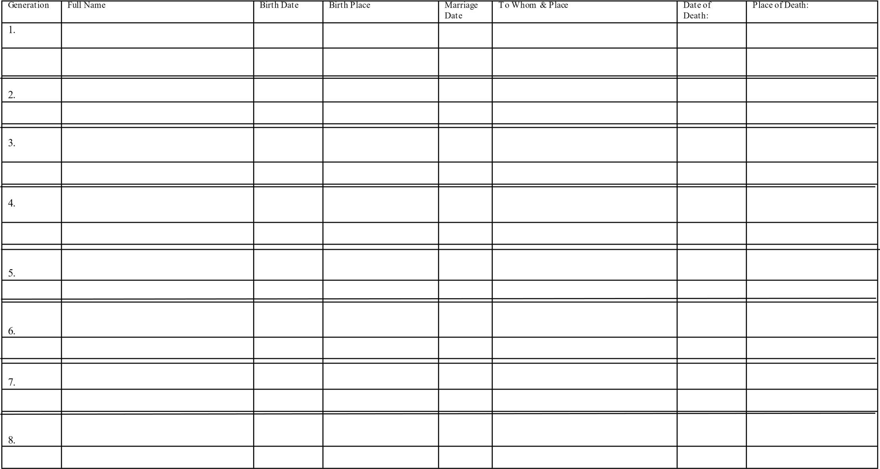

Swan River Pioneers 1829 - 1838 Inc.
An Affiliated Member of the Western Australian Genealogical Society Inc.

1. AIMS & OBJECTIVES OF THE GROUP
( a) To perpetuate and honour the memory of the early settlers for their enduring hardships and difficulties of the early years of the colony.

( b) To complete biographical and genealogical data of the pioneers and their families.

( c) To collect and preserve material of any nature which illustrates any aspect of pioneer settlement in th
the Swan River Colony of Western Australia.

2. GROUP MEMBERSHIP
- Membership of the Group is restricted to those whose ancestors settled in the Colony between 1st June 1829 and 31st December 1838.

- Associate Membership of the Group will be granted to those who have a genuine interest in the Early Pioneers of Western Australia

- Certified Membership shall be determined by the Convenor of the Swan River Pioneers Group and upon the recommendation of an Examiner of Proofs.

3. CERTIFED MEMBERSHIP & CERTIFICATES FOR NON-MEMBERS
( a) Will be available only to persons who can claim direct descent through proof certificates from the Registrar General and/or proofs in the form of manuscripts or other material relating to the arrival in the Colony.

PROOFS REQUIRED FOR CERTIFICATES OF DESCENDANCY
(a) Evidence of descent from the pioneer should be in the form of certificates from an official registry of births, deaths & marriages but wills, manuscripts or other material relating to settlement in the Colony can be submitted if certificates are not available. Documents submitted should be forwarded with the application and will be filed for our records. Photocopies are acceptable, provided they are legible, full size and complete.
( b) Evidence of settlement in the Swan River Colony may be in the form of authenticated information from the Registrar General or family papers. In the case of secondary sources such as published records, specific reference must be provided. We will need a copy of your Birth Certificate to prove line of descent.

( c) In the event of any such proofs not being available circumstantial evidence should be put before the Certificate Registrar for consideration. Acceptance of any such evidence will be at the discretion of the Certificate Registrar.

APPLICANTS ARE REQUESTED TO NOTE THESE FURTHER INSTRUCTIONS
- Please be sure to sign the form before forwarding.
- Documents must be legible.
- Photocopies should be clear, full size and complete.
- Married ladies please remember to show evidence of change of name, by including marriage certificate
- There is a once off joining fee of $10 to join the Group and it is $25 for the Certificate and badge
- Would applicants kindly forward $35.00 ($15.00 if current subscription fee of $25.00 has been paid) which will cover the cost of your joining fee, certificate, badge and an annual (4 issues) subscription to the Newsletter.
- Children of applicant can apply and cost of their Certificate is $20 if they do not require Newsletter.
(Cheques made payable to the ‘Swan River Pioneers) together with your forms to:
Certificate Registrar, Swan River Pioneers 1829-1838 Inc, PO Box 2672, Ellenbrook WA 6069
Mastercard & Visa Card payment accepted and you can also direct deposit payment to:
Swan River Pioneers BSB: 016 352 Account No: 306888364 (Please advise of payment by email)

- Where a Certificate of Descendancy recipient has more than one ancestor arriving in the Swan River Colony during the specified period and can prove direct descendancy – then extra certificates are awarded to this recipient at a cost of
$6.00 per additional ancestor. 3

